FIND OUT LATEST NEWS ON THE PROJECT
INTELLECTUAL OUTPUT N.2 IS READY! CHECK IT OUT!
IO2 A.C.C.E.S.S. SYSTEM FOR MONITORING AND PREVENTIVE SUPPORT AGAINST EARLY SCHOOL LEAVING
The A.C.C.E.S.S System is a complex and demanding output made up by two components corresponding to two phases:
- early warning component: a monitoring process of the risk indicators of ESL addressed to all students. The early warning system is based on specific indicators, descriptors, adopted from literature and from the research carried out as part of A.C.C.E.S.S project, and on the related risk thresholds. The monitoring process is led by all class teachers, under the Mentors’s supervision. Thanks to the monitoring action the school can regularly evaluate the intensity of the disengagement through indicators. How? We developed a specific app where schools teachers can easily check the situation of all students. For every student when an indicator goes beyond the threshold risk a warning light will be displayed.
- Intervention component: a support pathway aimed at students at risk. Thanks to this action the school can work immediately on “at risk” students by finding out proper actions to fight the student’s disengagement. The intervention programme is data-driven: it’s activated when students are flagged as "at risk" by the monitoring App. It is implemented through support pathways addressed only to students at risk. For those students the Mentors design and set up diversified actions, based on the specific risk behaviors detected. In this process, Mentors must actively interact with other class teachers, Coordination Commettee of A.C.C.E.S.S. System, the student's family.

A.C.C.E.S.S. System of monitoring and preventive support against Early School Leaving: operating cycle and roles

The picture above shows the whole process including actions and roles of all involved players.
- The first and the second boxes in blue colors (early warning system; monitoring) belong to the first face early warning component
- The tirth and the fourth boxes in green colours (intervention programme; support path) belong to the second phase Intervention component

FOCUS ON THE APP
As mentioned above for the monitoring process we created a specific app named “A.C.C.E.S.S Warning System”. It is a software that allows to record data and, on the basis of indicators and risk threshold before mentioned, to advise ESL risk situation.
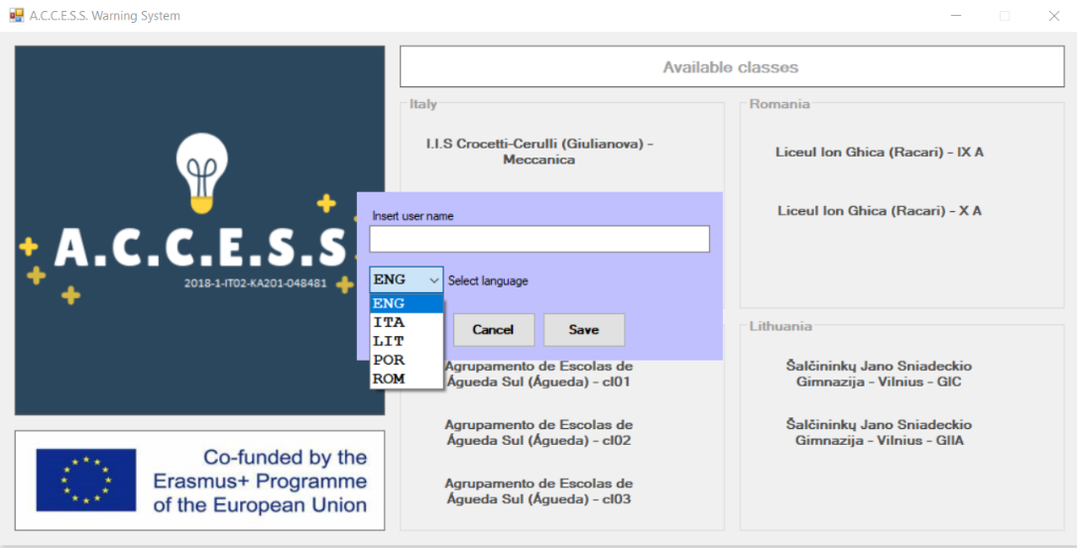

Each student has a dashboard with the ESL risk indicators to be monitored, associated with the various behaviors. The teachers must report them on the system on the basis of the behaviors they observe.

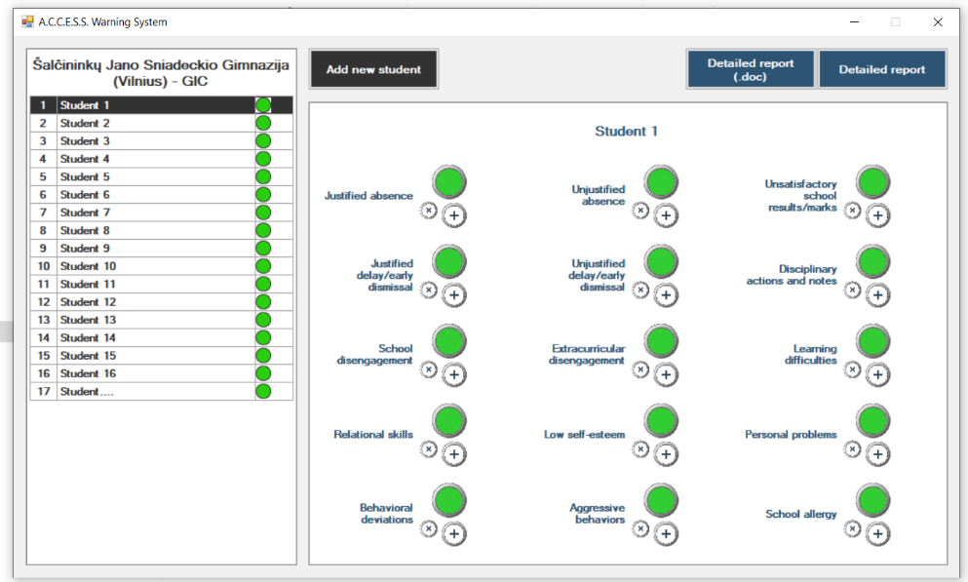

Student situation is monitored through the indicator lights connected to a double warning level:
  - red light if the risk threshold has been reached;
  - yellow light if the risk behaviors are close to the established threshold;
The green light means that no risk behaviors have been reported/entered or that these behaviors are far from the double warning thresholds.

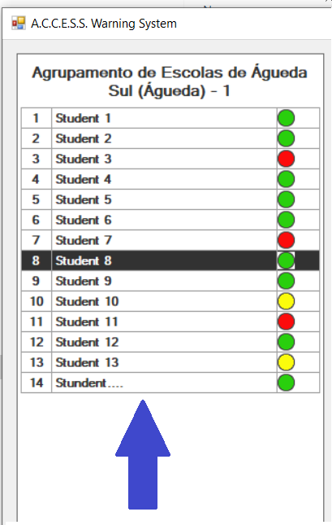

When a behavior reaches the risk threshold it’s time that the student is involved in an intervention program. Therefore, on student's dashboard, a graphic symbol "red question mark (?) will be activated for each risk behavior that has reached the threshold (red light on). This symbol means that a specific path linked to the type of risk behavior must be activated by the school.

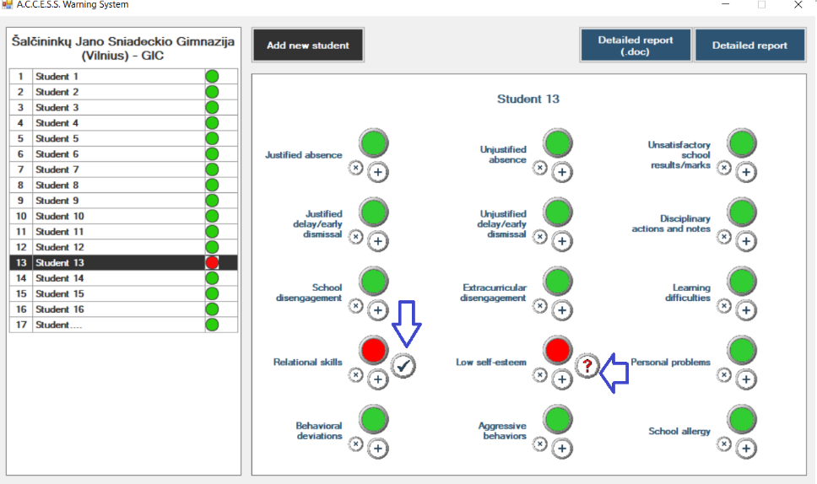

FIND OUT THE INTELLECTUAL OUTPUT N.3!
IO3 TOOLKIT FOR SUPPORTIVE TEACHING AND EVALUATION STRATEGIES

We developed Open Education Resources (in the form of a Toolkit) for the implementation of teaching strategies aimed at the creation of supportive and positive learning environments. The whole set of strategies (toolkit) is addressed both to students at risk of ESL (selective prevention) and to the whole class (universal prevention).
Toolkit intervention logic is based on preventive actions against ESL at the microsystem level. It means to have the student at the heart of the process, working on the environment and system of relations where student is directly involved (teachers, peers, school staff etc).
The toolkit is designed primarly for teachers of the first two years of upper secondary school taking into the account that the highest ESL rates are concentrated on these years.
Main features of the Toolkit:

- It adopts an holistic approach, by integrating several teaching strategies which prioritize social and emotional education;
- It uses a universal prevention strategy addressed not only to students at risk but to all students;
- It takes into account, in its prevention approach, tailored teaching methods and techniques;
- It works on building strengths for promoting growth and positive changes

IV (ONLINE) TRANSNATIONAL MEETING
On 29 June project partners met online for the fourth transnational meeting. Main points:
- presentation of temporary version of the app for the early warning and prevention system (IO2). Ilmiofuturo showed main characteristics of the app and how it works.
- Presentation of supportive teaching and evaluation strategies (IO3). Siuolaikiniu Didaktiku Centras made an introduction of the main strategies implemented, including example and asking for feedback.
- Current status for the identification of translators for IO2 and IO3
- Next steps: organisation of international learning activity for September 2020

